The Case for Opposing the Royston Gardens Development
JJ Royston LLC has applied for a sub-division hearing to develop five single family houses in the woods at the end of Royston Avenue--bordering Royston, Eunice, Burgess and Christopher. Residents are invited to submit their concerns to the City Planning Commission no later than November 27, 2018. All feedback from the community receives full weight in the Planning Commission’s decision. Please contact City officials to make your opinions about this development heard (list at end of document)!
__________________________________________________________________
KEY POINTS
- The 1773 Christopher Cemetery is located on the site. Historic cemeteries don’t have clear boundaries and at least several dozen burials may be desecrated if these houses are built. The Christophers were the original colonial settlers of the Westfield area.
- This 1-acre forest patch is Westfield’s only undeveloped green space, and an important habitat for local wildlife. Many residents would like to see the woods restored – with walking paths and a memorial for the Christopher family.
- After foreclosing on the cemetery, the City sold it for $5 to be developed, without removing the human burials. That original foreclosure, and our current situation, showcases the City’s pro-development stance and continued lack of consideration for the needs of Baltimore communities and residents.

BACKGROUND
- If his paperwork is in order, why shouldn’t Jeffrey Jackson be allowed to develop his land? Jackson has a bad track-record of following regulations. In 2007, he clear-cut a large portion of the woods without the city’s approval. In 2015, he applied for subdivision approval without informing the community about the Planning Commission hearing--also strictly against policy. Most importantly, he has ignored the Christopher family’s request for a full archaeological survey to identify human remains (at the very least, for re-interment). Experts such as the Commission for Historical and Architectural Preservation (CHAP), Herring Run archaeologists, Baltimore Heritage, and the Coalition to Protect Maryland Burial Sites have all emphasized that historic private cemeteries do not have clear boundaries. We should expect burials outside of the cemetery boundaries (particularly servants/slaves, non-family members and others with lower social standing). It is estimated that at least several dozen unmarked burials could be desecrated if the development moves forward. Having set aside less than 10% of the formal cemetery area, Jackson stands to benefit from a tax credit that compensates property owners for preserving cemetery grounds. He does this without the Christopher family’s approval. The family has a list of unaccounted relatives whose burials may be paved over or plowed through if the development moves forward. Mr. Jackson knows this. In fact, he consulted with the Office of Cemetery Oversight to clarify that it is not specifically illegal to “pave over graves” (because it is extremely likely there are human burials where he plans to extend Royston Avenue and add parking pads for the houses). It is fundamentally immoral to install a stormwater management system and build homes where human graves are present.
- The developer has not consulted with the Maryland Historical Trust, as required by law. Revisions in Maryland Cemetery Law in effect since June 2018 require that “the owner of any burial site or land encompassing a burial site that has been in existence for more than 50 years” must consult with the Maryland Historical Trust (MHT) about markers, human remains, and the surrounding environment before proceeding. Mr. Jackson has not submitted his development plans for review. The City Planning Commission has stated that Mr. Jackson’s consultation with the MHT will NOT be required for a subdivision approval. Let the Planning Commission know that, in brushing over this requirement, their office is ignoring Maryland State Law!
- Mr. Jackson operates Stonewall Capital, a large development company, which completes major subdivision projects throughout Maryland. Royston Gardens is small in comparison to the 25+ housing and condominium developments that have been in their pipeline elsewhere. Jackson is not a Westfield resident, nor local business owner. WNIA represents the interests of Westfield residents and local businesses, not absentee developers. If the land were to become a park or land trust for the benefit of the community, negotiations mediated through the City (such as a land swap) could ensure that this influential developer would not suffer financial loss.
- There is no clear way that this housing development benefits Westfield residents. One might hypothesize that five new homes could improve property values. However, in 2015, a group of residents petitioned nearby neighbors and opposition to the development was overwhelming. A common sentiment was, “five houses can’t possibly fit back there.” Many were concerned about the cemetery. Many were furious that the City would allow the neighborhood’s only undeveloped green space to be cleared for new homes that seemed unnecessary (many existing homes stood vacant). Residents living nearby overwhelmingly expressed that landscaping and restoration of the woods and cemetery were preferred, and that this would improve property values. A commercial development along Harford Road might draw opposing views (possible drawbacks of a development would be countered by the value of new business services). However, for a housing development that clear-cuts an acre of undeveloped urban forest in a quiet residential area, destroying the 18th c. historic cemetery of the family who settled the community, the cost to residents seems to clearly outweigh the benefit.
- The City’s original foreclosure and sale was problematic. In 1962, the City foreclosed on the land encompassing the Christopher Cemetery when Samuel Christopher died owing back taxes. The family did not know Samuel owed taxes and was given no chance to pay the debt. Building new homes to increase the tax base was prioritized, and the City sold the land to the Acalo Corporation for $5 in 1965. The Acalo Corp. never developed the land—perhaps due to the cemetery, or the stream running beneath the property. By legal standards, the Christopher Cemetery was not an “abandoned cemetery” before the foreclosure. It was recognized by the community and visited and maintained by relatives. Only after the property was foreclosed on did it become overgrown and gravestones were vandalized and stolen. Maryland State Burial Law states that the sale of a cemetery for use for another purpose requires a court judgement. The purchase price is then used to pay for the re-interment of human remains. If a court judgement had been enacted in 1962, an archaeological survey could have more easily identified burials. Graves and monuments were intact, and the property was not in a condition of neglect. In the 1960s and 70s there was a pattern of foreclosing on private cemeteries at the city’s outskirts to make way for new development. The development of a strip mall on Laurel Cemetery, the large African American cemetery off of Belair Road, is a prime example. It is unethical to develop “abandoned” private cemeteries without offering a new final resting place for the dead. Many states have laws prohibiting this practice, and Maryland is in the process of strengthening its cemetery law. The Christopher family believes the City has the obligation to correct this wrong and assist them in ensuring that their loved ones may rest in peace.
- Westfield families living downhill from the property worry that the stream beneath the woods, if disturbed, will cause water damage to their homes. When the WNIA held a Fall 2015 meeting to discuss the development, households living downhill shared emotional stories about water damage. In particular, residents living on Pinewood, Rosekemp and Cederhurst Avenues have experienced basement flooding. They’ve expressed concern that disrupting the waterflow of the stream beneath the woods will cause property damage. The underground stream flowing beneath the forest forks and runs downhill to Moyer Ave to the East and downhill beneath Westfield, Pinewood and Fleetwood Northward. When Mr. Jackson’s engineer was asked about his plans for managing the stream in 2015, he had not known of its existence. Stormwater management is listed as a specific interest for the Planning Commission’s subdivision approval. However, the Department of Public Works (DPW) does not review stormwater management plans until after the subdivision hearing. Subdivision approval is the ‘green light’ for the development to proceed. When the DPW later reviews the development’s stormwater management system, there are no public hearings and no opportunity for community input. We believe the DPW may not have been informed of the underground streams and residents’ concerns about water damage. The development area rests on the Back River Watershed--one of the most problematic and polluted watersheds flowing into the Chesapeake. Before subdivision approval is granted, we’d like this issue to be investigated, to ensure the development would include precautions to contain the stream flowing beneath it (see figure 1).
- “Paper alleyways” will be widened, likely paved, and accessible for vehicles. Before the woods became overgrown, a system of well-maintained paper alleyways (with grass underfoot) once served as walkable pathways connecting the avenues of Burgess, Royston, Eunice and Christopher. Residents used them for dog walking, riding bikes, and family strolls. The WNIA has discussed the possibility of a community “Green Alleyway” project, clearing underbrush and debris, adding landscaping, and restoring them as paths for foot traffic. Many streets in our community lack sidewalks. Green Alleyways introduce green, car-free corridors, making communities more walkable and creating social space. The Royston Gardens development widens the public alleyways so that they are accessible to automobiles. The alleyways are listed as ‘no access’ (they are not formal roads). However, they will be wide enough for vehicles to drive from the end of Royston Avenue to the corner of Christopher Ave and Eunice. The quiet one-way corner of Christopher and Eunice will become a three-way intersection.
- The land represents a valuable heritage and ecological asset for the Westfield community. Throughout Westfield and Hamilton Hills, street names remind us of the Christopher family who first settled the area. Avenues--such as Christopher, Eunice, Louise, Edna, Mary, Bertram, Richard, Theodore, Milton, etc.--are all dedicated to the legacy of the Christopher Family. The Christophers were Quakers, a religious group dedicated to simple living and human equality. The Quakers banned slavery for their members in 1761, were active in the underground railroad, and supported land rights for Native Americans. Wouldn’t it be interesting to preserve our local history, and discover more about this? If Royston Farms destroys the Christopher Cemetery, the potential for commemorating local heritage is forever lost.
The pocket forest is also an invaluable green space. It is approximately one acre and represents the only undeveloped space in Westfield. From an aerial view (see fig. 2), one sees that this triangular pocket connects with a corridor of narrow wooded passages. These woods are a habitat refuge for area wildlife--racoons, foxes, opossums, groundhogs, rabbits, bats, frogs, hawks, woodpeckers, hummingbirds and other native birds. The survival of area wildlife could be significantly impacted by the development. There are no parks in Westfield. The closest public park, Burddick, is a fifteen-minute walk. Burddick is a smaller park, with no dense tree coverage, so it has limited use as a wildlife habitat. Many in the community would like to see the landscape restored as a green corridor—with walking paths and benches and a heritage marker dedicated to the Christopher Cemetery.
The fact that a parcel of land is “private property” should not override all other priorities of urban planning. There are dilapidated properties throughout Baltimore City that could benefit from a development such as the one Mr. Jefferson is proposing. However, the heritage value of the Christopher Family Cemetery is unique and unexchangeable. If restored and commemorated, the Christopher Cemetery would be an important asset for our community, helping shape Westfield’s sense of place, and familiarizing residents with local history. Similarly, when an undeveloped forest patch is flattened for a housing development, the potential of that green space is lost and cannot be brought back. The City of Baltimore’s 2009 Sustainability Plan notes: “Parks, gardens, fields, and other recreational areas […] raise home values.” It admits that “[m]any of Baltimore’s regulations regarding trees need updating to meet goals and standards for contemporary urban forest practices.” If the forest patch at the end of Royston Ave. is developed, the community will lose so much more than the monetary value of $11,000 that Mr. Jackson paid for the land. Without re-interring the graves, the City should never have sold this parcel for development. Residents opposed to Royston Gardens feel that the proper solution would be for the City to intervene and offer the developer compensation or a land exchange. Neighbors are also willing to create a land trust and apply for grants and loans to cover the property’s purchase. Preserving the wooded lot at the end of Royston Ave. would be a valuable long-term investment in Westfield, significantly benefiting its residents. These woods are a sacred space and a natural space, and a valued part of the community’s cultural landscape.
- There are no disadvantages to opposing this development. Mr. Jackson’s original 2007 design included driveways that connect several one-way streets, changing traffic patterns. He removed these curving driveways when residents complained. Residents also criticized the original name of the development, “Stonewall Gardens,” stating that a housing development named after a Confederate General was in bad character and would have a negative impact on the community. The developer changed the name to “Royston Gardens.” The Christopher Family does not wish to accept the developer’s offer of a small parcel of the original cemetery without also fighting for an archaeological survey to locate remaining unmarked graves.
Supporting the development would open an avenue of communication to negotiate small alterations, such as the external appearance of houses, or a few additional trees. But if Westfield opposes the development, it may still negotiate alterations through the Planning Commission. TreeBaltimore makes free trees available to city neighborhoods, should we wish to increase our tree canopy. There is little more to negotiate relating to the existing development plans. Voting “no” carries little risk for WNIA, but it does offer opportunities. It empowers the the community to make its opposition known to city officials. It offers us the opportunity to open a dialogue with city officials, to negotiate an alternative solution that could save the forest patch and cemetery from development. Voting “no” empowers the WNIA to submit Association backed letters to influential parties. Voting “no” to this development enables the Association to officially back the many residents whose quality of life and property values could be negatively impacted. It enables us to begin envisioning a community green space and a cemetery heritage memorial, and to take action to make this a reality. If the development moves forward, regardless, Westfield residents will respect the WNIA for having made an effort in supporting the community’s best interests.
Fig 1 – Pattern of Underground Streams
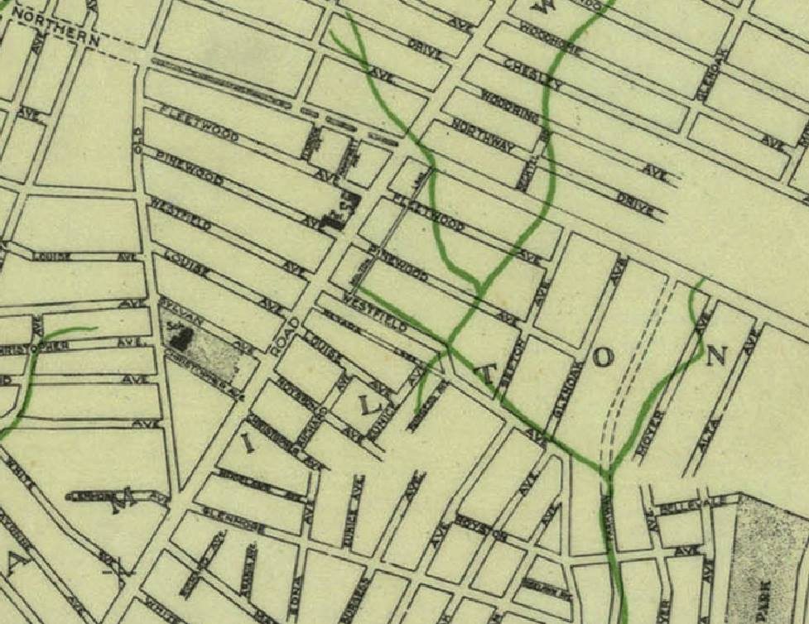

Fig 2 – Aerial view of woods
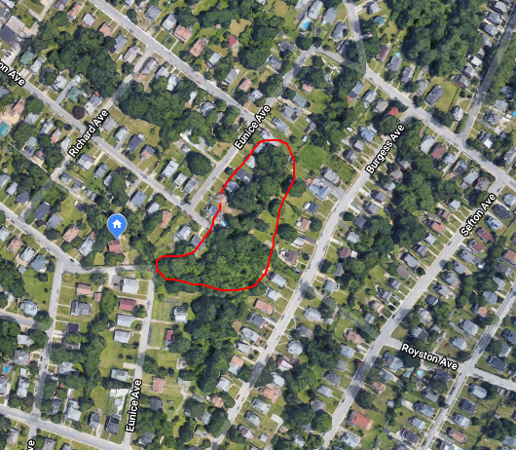

Tell City Officials and Political Representatives What You Think!

Planning Commission MD Office of Cemetery Oversight
Matthew DeSantis, AICP Deborah Rappazzo, Executive Director
City Planner, Land Use & Urban Design 500 N. Calvert Street, 3rd Floor
Baltimore City Department of Planning Baltimore, MD 21202-3651
417 E. Fayette Street, 8th Floor 410-230-6229
Baltimore, MD 21202 deborah.rappazzo@maryland.gov
(T) 410.396.5622 (F) 410.244.7358
matthew.desantis@baltimorecity.gov

City Council
Ryan Dorsey - District 3 Council President Bernard C. "Jack" Young
410-396-4812 410-396-4804
410-396-8621 (fax) 410-539-0647(fax)
100 Holliday Street 100 Holliday Street
Suite 500 Suite 400
Baltimore, Maryland 21202 Baltimore, Maryland 21202
Ryan.Dorsey@baltimorecity.gov CouncilPresident@baltimorecity.gov

Office of Mayor Catherine Pugh

Tonya Miller Kendra Parlock
Senior Director of Public Affairs Director, Mayor's Office of Sustainable Solutions
Tonya.Miller@baltimorecity.gov kendra.parlock@baltimorecity.gov
443-984-3608

Daphney D. Williams Attorney General’s Office (can order a full archaeological survey)
Director, Office of Constituent Services Marilyn Mosby, State’s Attorney
Daphney.Williams@baltimorecity.gov 120 East Baltimore Street, 9th Floor
(410) 396-4900 Baltimore, MD 21202
mail@stattorney.org
State Representatives
Delegate Cory CoMcCray, 45th District Delegate Talmadge Branch, 45th District
House Office Building, Rm 315 1812 Ashland Avenue, Suite 507
6 Bladen St., Annapolis, MD 21401 Baltimore, MD 21205
410-841-3486 410-841-3398
Cory.mccray@house.state.md.us talmadge.branch@house.state.md.us

Delegate Elect Stephanie Smith Delegate Cheryl Glen
P.O. Box 41120 413 House Office Building
Baltimore, MD 21223 6 Bladen Street
Stephanie.Smith@baltimorecity.gov Annapolis, MD 21401
410-841-3257
cheryl.glenn@house.state.md.us

